“Foreign policy as a Tool of State-Building”
Research workshop

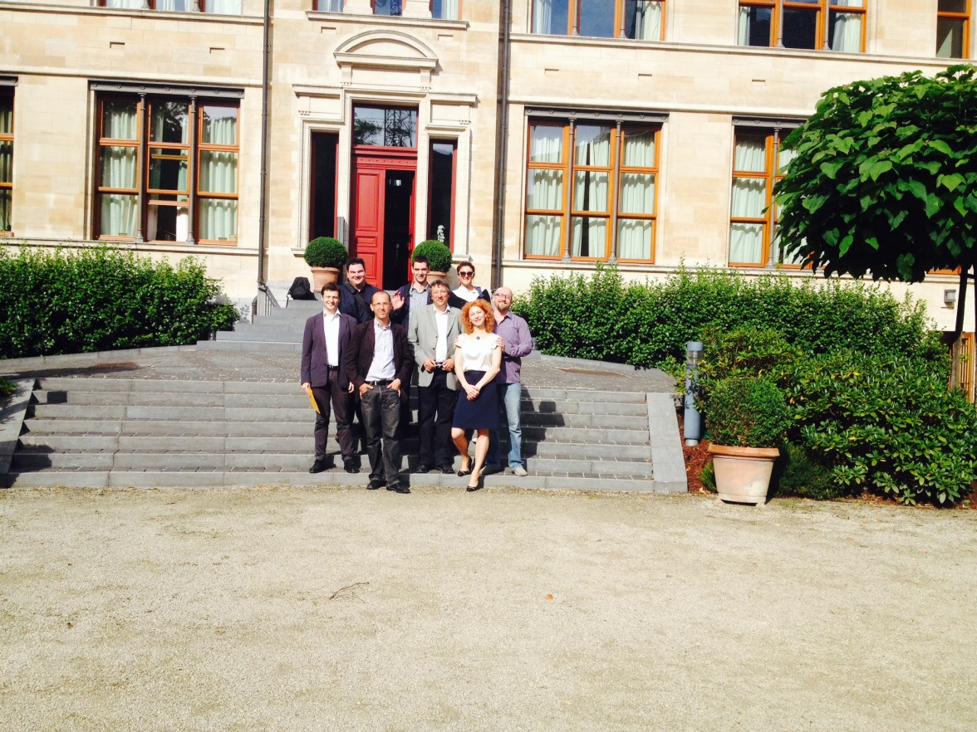
7th July 2014
Representation of the Free State of Bavaria to the EU
Brussels
Summary Report

The research workshop took place on the 7th July 2014. The workshop was kindly hosted by Dr Philipp Steil at the Representation of the Free State of Bavaria to the EU in Brussels and was chaired by Prof Dr Bernhard Stahl, Professor of International Politics at the University of Passau, Germany and Dr. Soeren Keil, senior lecturer in International Relations at Canterbury Christ Church University, UK. The academics presenting their ongoing research were: Prof Dr Zlatko Sabić, Dr.Senada Selo Šabić, Dr. Jelena Džankić, Mladen Mladenov, Adnan Huskić and Gëzim Krasniqi.
The workshop was also attended by:
H.E.M Mario Nobilo, Ambassador of Croatia to the EU; Marianne Ebertowski, Heinrich Boell Foundation; Dr Stefan Gehrold, Director, Konrad Adenaeur Stiftung Bruessel; Andon Sapundzi, Minister-Counsellor at the Embassy of the Republic of Serbia to Belgium; Valeza Oruci, Kosovo Embassy to Brussels.
About the Project:
This research project on Comparative Foreign Policy in the Western Balkans fills in a gap largely left un-noticed by contemporary political science. Scholars from the former Yugoslav states write and discuss about the formation of an independent foreign policy in their respective states, the approach of each state towards EU Enlargement and state attempts of reconciliation after the disruptive Balkan wars of the 1990s. Further aspects discussed are the creation of a security community in the Balkans and the state/nation problem of the newly formed countries.
Summary of presented research and discussions:
The workshop was considering foreign policy as a tool of state-building in the post-Yugoslav States.
Dr. Soeren Keil - Introductory words:
When discussing foreign policy as a tool of state-building it is important to consider the definitions. David Chandler's defines state-building as the process of building effective state institutions at local, regional and central level. Christopher Hill sets out the definition of foreign policy as the interaction of 'our' state with other states and actors in the international environment.
The key to link the two is legitimacy: state-building to ensure internal legitimacy, while gaining external legitimacy through foreign policy.
In the post-Yugoslav space these two forms of legitimacy overlap. State building has been used as a tool of foreign policy to connect internal and external legitimacy. Foreign policy has also been used as a tool of state building. For example: republika srpska ties to Serbia; Slovenia rebranding itself as a Central European country; the Kosovo - Serbia - EU triangle; and Tudjman's rejection of the EU after 1995.
Yet, because we are looking at relatively new states, we would expect the two to overlap
1990: elites come to power on the basis that they are:
a) against communism
b) pro-independence
c) for the continuation of Yugoslavia
So, from the beginning of these states' presence in the international arena questions of state building and foreign policy were central....
1) Legitimacy of secession/state dissolution
2) Violent conflict ( BiH -civil war? )
3) Borders
4) Role of external actors in the area after 1991

Today we have a situation whereby foreign policy is key for internal and external legitimacy.
There are cases where state building and foreign policy are completely interchangeable:
i.e. - the role of the EU in Kosovo/Serbia
The role of the EU in political systems in BiH and Macedonia
-> The EU becomes a domestic actor
Where does this leave us?
- Why is there so little theoretical research on the topic?
- With many interesting / important questions for the post-Yugoslav States

The need to re-conceptualise key IR terms such as:
- Sovereignty
- Independence
- Legitimacy
- Opens new theoretical and empirical puzzles that will help explain some FP decisions and might allow us to predict future decisions
- Defects of state/nation building and its consequence for the foreign policy
- Practical relevance for policy

Prof Dr Zlatko Sabić - Slovenia.
Is Europe an answer to the current issues in the western balkans/ post-Yugoslav States? Nation building has an impact on state building.
Common understanding of the past = problematic. History matters for state building and foreign policy. FP -> priorities ; relationship with neighbours ; relationship with other external actors.
For instance: institutions were set up and calibrated to EU institutional infrastructure and norms but the environment was saturated with unresolved issues from the past - this leads to negative impact on FP.

1990s-
Political elites -> had to differentiate themselves from 'war-waging' Balkans. FP focus on membership of EU/ NATO. The image in the EU of Slovenia as a role model.
2004-2008
Project-based foreign policy - with a lack of consistency between international actors - the OSCE, EU, CoE.
2008 onwards
No fixed FP - this non-existence of foreign policy has negative effects on state building. Problems with embassies and different preferences; state failures with law suits from the European court of human rights; general lack of real direction.

Discussion, questions and comments:
To what extent should you expect Slovenia to have a strong FP?
Slovenia declared independence too early - Slovenia and Croatia were selfish at the time.
What is Slovenia's view on the Balkan States that are "lagging behind"?
Does "no common view of the past" lead to apathy?
Responses:
Discourse surrounding Slovenia's independence presented those who wanted a confederation as merely not brave enough to push for full independence. In fact , it should have been done in a more mature way. After it's ambition to join the EU Slovenia's FP becomes blurred. Despite its efforts to rebrand as a Central European country on many levels Slovenia is highly connected with the rest of the western Balkans......e.g economy, culture, sport. Central Europe is important but there are still strong links with the western Balkans.

Dr.Senada Selo Šabić - Croatia
How to discuss FP as a tool of state building?
Look at institutional/ bureaucratic side of state building and the role of elites.
Thematic:
- collaboration with non-state actors
- state building
- cooperation with NGOs -> and their influence on state building
- position of civil society supported from outside actors
- position of judiciary supported by outside actors

Sequencing
1990s - '94
One face of FP - with the state in conflict, FP focus is on recognition. FP actions , such as the Washington agreement aim towards building the state.
1995 - 2000
Tudjman's views and authoritarian rule , severed connections with other foreign policy contacts.
2000 – 2013
The death of Tudjman , the HDZ losing power led to changes.
The full consensus - membership of NATO and then accession to the EU.
2013 - present
A new phase of Croatia foreign policy.
Transfer conflict knowledge.
Energy policy niche policy.
Questions and comments
What is/has been the role of the EU? In Serbia the EU actually intervened in domestic elections – did this happen in Croatia?
Where is the future? In energy, tourism? What is the future image for Croatia? What vision in 15 years’ time for tourism?
What about Croatia’s position towards the Croats in Bosnia and Herzegovina?
Responses:
I am not aware of any direct intervention by the EU in the election process. They did encourage NGOs – including one that involved elections – thus strengthening NGO sector and legitimacy.
Croatia is very keen on environmental policy; energy plants; environmental concerns; and tourism.
With regard to Croats in BiH – Croatia’s Foreign minister is highly supportive in attempts to speed up Bosnia’s accession to the EU with the large Croat population in mind - Croatia will not give up on BiH.
Post EU accession there has not been much in the way of FP from Croatia. We should be offering our expertise to others - but we are not. Adriatic is the key – tourism, shipping, maritime. We need to build a strategy. The future is not in mass tourism but we should aim to become a destination as a second or permanent home for other Europeans. (Comments from Croatia ambassador Mario Nobilo)

Dr. Jelena Džankić – Montenegro
Montenegro Foreign Policy – three main areas
- Means of decoupling from FRY
- Mechanism for state building following independence
- Mechanism for constructing identity
Decoupling from FRY –
In the early 1990s – Detachment from institutions of FRY. Supported by the West – huge financial aid (unconditional) helped and underpinned the creeping independence project.
1999 – Separate visa regime was introduced. Special category of citizenship – not attached to FRY. By 2001 Montenegro had opened several offices.
Post- Milsosevic: mounting independence drive.
FP used as a tool of state building after 2000.
2002/2003 – FRY transformed into union of Serbia and Montenegro – “solania”.
2006 – Independence referendum – the EU intervened in rules of the referendum ( approval would need 55% of votes) it narrowly passed this with 55.5% of votes.
Foreign Policy as identity construction:
2003 consensus highly polarised on identity. FP as a mechanism of showing EU orientation. Support for EU integration is reasonably high, but it is less so for joining NATO.
Questions and Comments
How is decoupling different from independence?
EU and NATO – what after this?
What is support for US and Russia since 2010?
Responses:
Decoupling is a unilateral action, state building is more collaborative.
Support is higher for Russia than for the US.
EU and NATO, What after this? We’ll see.

Mladen Mladenov – Serbia
Main Characteristics under DS government
Four + Two pillars
- USA
- Europe
- Russia
- China
- NAM (non-aligned movement)
- Neighbours
Different prioritization on different occasions – some contradictions.
Under SNS (since 2012)
- Stronger focus on European integration
- Acceptance of de facto loss of Kosovo
- Improve position of Serbs in Kosovo
- Significance of ROW (rest of world) to Serbia
- Relationship with Russia
Clearer prioritisation of goals with less contradictions
Foreign Policy of counter-secession:
-Prevention of recognition of Kosovo by as many states as possible
-Preventing Kosovo’s membership in International organisations
-Goal = preserve the idea of the state as it exists
Impression Management (IM) – the process to control the impression of others.
For domestic purposes:
To create the impression of not betraying national interests.
For International purposes:
To create the impression of being truly remorseful for past wrongs. Apologising in western media.
Foreign Policy is not just there to confirm the existence of the state. It is to facilitate the building of a state in accordance with existing, deep-lying ideas of the state. Also to create a positive impression abroad, while maintaining the image of the state at home.

Adnan Huskić – Bosnia and Herzegovina
Phases of Foreign policy reflected in state building:
- 1991-92 – Independence, immediate post-independence, building a state
- 1992-95 – War-time , internal legitimacy
- 1995-2006 – Post-War - less power for entities, FP excusive competence of State. Heavy international intervention. OHR as a domestic actor, internal and external policy overlaps.
- Post 2006 – State building by local actors, the need for engagement by internal actors and stronger state building at entity level. Needs to be a collaboration and dynamic between constitutional reform, EU accession requirements, international actors, member states and kin states and domestic political elites.
The EU enlargement framework needs to accommodate different problems that exist in BiH.
A final phase can be added:
- Post Sejdic-Finci
The end of Bosnia? International legitimacy without internal legitimacy, nor an independent FP – limits in the constitution and heavy reliance on kin states by the entities.

Gëzim Krasniqi – Kosovo
Contested Statehood – Internal: Serbs in Kosovo; external : International split. 5 EU members do not recognise Kosovo. Russia hinders progress. Members of IMF and World Bank but not FIFA or UEFA. 22 embassies abroad, and a visa regime for 87 countries – yet it is still isolated.
1999 began the main period of state building….2008 – declaration of Independence.
International pressure – EU pressure for technical, and then political dialogue. It is necessary for EU progression to demonstrate that they can negotiate with Serbia. EU Progression for both Serbia and Kosovo is affected by the situation. There are also difficulties with nation building due to the internal divisions – there is no nation building through institutions with two national understandings – the Kosovo nation and the wider Albanian nation, resulting in confusion with a contested state and contested nation.
Comments and questions:
There are obviously problems with identity and the nation – which affects EU accession. Can Europeanisation be categorised as Foreign policy here? It is important to recognise the role of international actors in domestic affairs. State building overlaps with FP – or does it clash? It raises the issue of how to theorise the link between foreign policy and state building.
Conclusions following the workshop.
The discussion has raised four main areas:
- The link between state building/ consolidation and EU integration
- The link between international actors’ involvement in domestic affairs and state consolidation
- When does state building and Foreign Policy…: overlap? (war); clash? (Kosovo v EU integration in Serbia); or harmonise? (consensus on EU integration)
- How can we theorise the link between state building and FP?
- Identity – state building – EU integration
- Policy relevance
- Advocacy of a roadmap
- Europeanisation of FP

The research group is currently presenting its draft papers on international research conferences like UACES and ECPR. Additionally, there is a book being planned on Comparative Foreign Policy in the Western Balkans.

